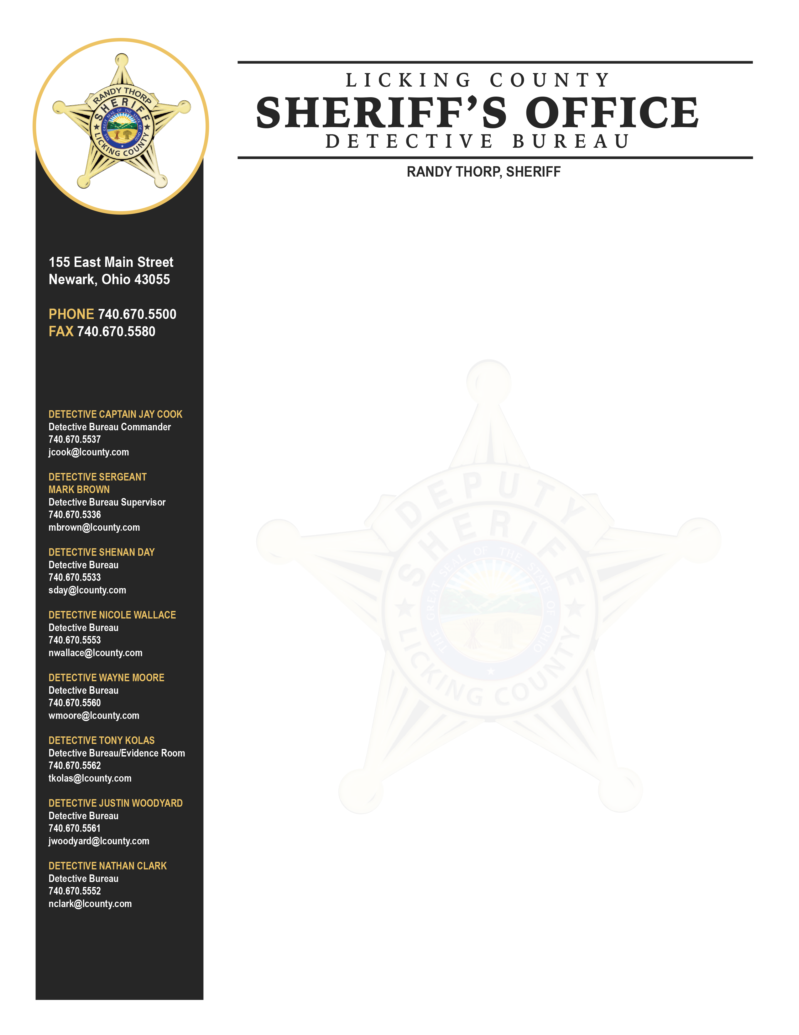

The Licking County Sheriff’s Office began a sexual abuse investigation in February of 2025 after a request from the Knox County Sheriff’s Office. As a result of the investigation on April 18, 2025 Detectives secured and served an arrest warrant for Gary Thomas Keesee JR. (11-23-88). He was arrested at his residence, 9340 Miller Rd. Johnstown, Ohio, without incident. The warrant is for two counts of rape, both felonies of the first degree. At the request of the Knox County Sheriff’s Office, Mr. Keesee will be held in the Licking County Justice Center. His case will be heard by a Knox County Grand Jury on Monday, April 21, 2025 where more charges will be considered.
After Grand Jury on April 21, 2025 there will be a joint press conference with the Licking County Sheriff’s Office and the Licking County Prosecutor’s Office at the Licking County Sheriff’s Office.

DETECTIVE CAPTAIN
JAY COOK
Detective Bureau Commander
740.670.5537
jcook@lickingcounty.gov

DETECTIVE LIEUTENANT
GUS MOORE
Detective Bureau Supervisor
740.670.5564
gmoore@lickingcounty.gov

DETECTIVE SERGEANT
JUSTIN WOODYARD
Detective Bureau Supervisor
740.670.5561
jwoodyard@lickingcounty.gov

DETECTIVE TONY KOLAS
Detective Bureau Evidence
740.670.5562
tkolas@lickingcounty.gov

DETECTIVE WILLIAM BOWMAN
Detective Bureau
740.670.5533
wbowman@lickingcounty.gov

DETECTIVE NATE CLARK
Detective Bureau
740.670.5552
nclark@lickingcounty.gov

DETECTIVE SHANE ROCKEY
Detective Bureau
740.670.5553
srockey@lickingcounty.gov

DETECTIVE KAYLIN LEE
Detective Bureau
740.670.5530
klee@lickingcounty.gov

DETECTIVE JONATHAN MILLS
Detective Bureau
740.670.5565
jmills@lickingcounty.gov

DETECTIVE CORY BURGESS
Detective Bureau
740.670.5560
cburgess@lickingcounty.gov

DETECTIVE SARAH MCCREERY
Detective Bureau
740.670.5558
smccreery@lickingcounty.gov

